**Next Phase Website Functionality**

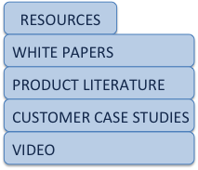We need support for deeper navigation in the menu.  
  
Currently the menu only supports going 1 level down:  
  
  
  
As we make the site more content-rich, we will need to inform visitors that there are other pages below the ones they can see. For instance, both the Products and Industries pages have sub-pages today, but there is no way to see them in the navigation. And, if you do not happen to put your mouse over the on-page links, you would never know they are there.  
  
Also, as we add more content, the Resources section will need to be subdivided into subsections. At present the following navigation sections are envisioned:  
  
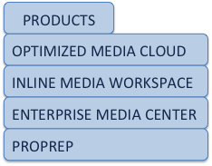  
  
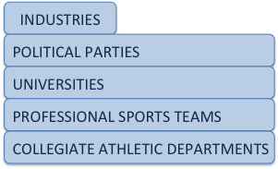  
  
As indicated, the sub-page names will be left-justified in the pull-down, and the width of the pull-down will be dynamically determined based on the longest sub-page name.  
  
The sub-menu should appear upon mouse-over, and the different pages in the menu list should highlight as the mouse rolls over them … this may cause some thinking/re-thinking about how the highlighting works now … clicking on any entry takes the visitor to the specific sub-page of interest.

It is possible that we may want to get super creative and allow for one further level of navigation, like this:

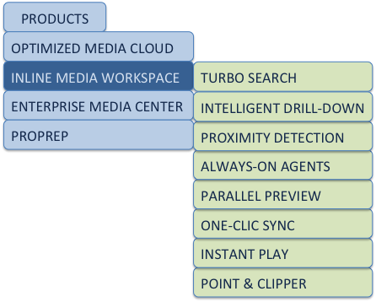

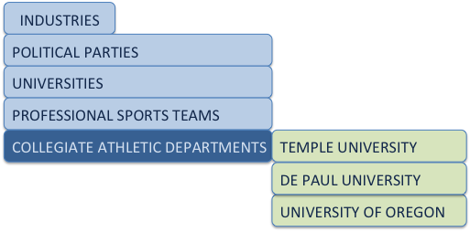

This kind of generalized navigation will enable us to create as much depth as we want in the site and make the site structure and individual pages visible from virtually every page.